Joint Research Day 2023
Department of Experimental Surgery,
Injury Repair Recovery Program & Experimental Surgery Graduate Student Society Wednesday, February 22nd, 2023
L’Espace Canal
ABSTRACT FORM THE DEADLINE FOR SUBMISSION IS FRIDAY, DECEMBER 9, 2022
Your name | Zanib Nafees, MSc, PhDC
Supervisor’s name: | Dr. Dan Poenaru, MD, PhD
Supervisor’s Division: | Pediatric Surgery
Are you a student? Please indicate your level | Yes☐ No☐ MSc1 ☐ MSc2+ ☐ Med Student ☐  PhD1 ☐ PhD2 ☐ PhD3 ☐ PhD4+☐
Guidelines: | Abstracts should be typed using 12-point Arial font and should not exceed one page, including diagrams.

TITLE | Adaptation and translation, and Validation of the Patient Reported Experience Measure for Children and Young People (PREM-CYP) at The Montreal Children’s Hospital
AUTHOR(S) | Zanib Nafees, MSc, PhDC,¹  Dan Poenaru, MD, PhD,²  Julia Ferrera, MD, MScC,²  Elena Guadagno, MLIS,²  Jo Wray, PhD³
AFFILIATION(S)  For each author | ¹Department of Experimental Surgery, McGill University Health Center  ²Department of Pediatric Surgery, Harvey E. Beardmore Division of Pediatric Surgery, McGill University Health Center  ³Great Ormond Street Hospital for Children (GOSH), London, United Kingdom
INTRODUCTION:
Patient Reported Experience Measures (PREMs) objectively evaluate children and youth’s perception of their care. However, use of PREMs is limited and generalizing any local data to larger populations remains to be accomplished. PREMs are useful as they reflect on the quality of care, are feasible, and are time effective. The utility of PREMs is seen in public reporting, institutional benchmarking, and health care plans. PREMs data can improve patients’ experiences in waiting times, communication, and team coordination.
METHODS:
This study will be a mixed-method research design that uses qualitative methods in Phases 1 and 2, adapting the existing PREM-CYP instrument to the MCH and translating it to French. Quantitative methods for Phase 3 will be used to cross-validate the MCH English and French versions.
Research Participants: Around 12-15 patients in the age groups (8-11, 12-13, 14-16 years) at the pediatric surgery clinics will take part in each session; think-aloud testing, cognitive testing, and bilingual validation).
Below is a diagram for the different phases of the study:
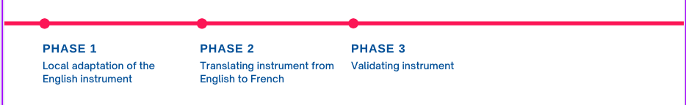
RESULTS:
We anticipate that by examining the meaning of the healthcare experiences of the children and young people (CYP), we will be able to generalize the results to other CYP in different settings.
CONCLUSIONS:
Our dissemination goals are:
1) to ensure that the voices of CYP are heard regarding their patient reported experiences (PRE),
2) to increase the acceptability of generalized data over a larger population by translating PREM-CYP_MTL from English to French, and
3) to ensure instrument compatibility with the CYP population of Montreal by having a bilingually validated PREM-CYP_MTL.

